The Glenwood School for Boy’s Special Use Application
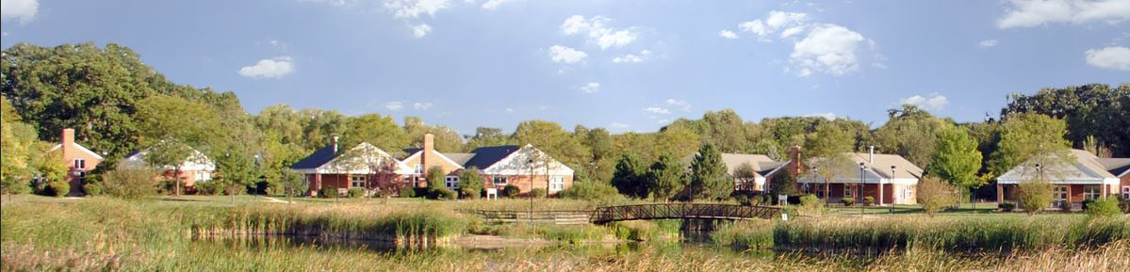
Our proposal is to convert The Glenwood School for Boy’s Campus into a luxury Alcoholism and Substance Abuse Treatment Facility. The existing layout of the school is perfectly designed to offer comprehensive treatment for adult men and women. The existing eight residence dormitories will house the patients, with separate buildings for men and women; two additional residence dormitories were planned. The patients will be grouped according to their needs and the type of treatment they will be receiving. A state of the art security system will be installed, and the facility will provide 24 hour security services. If a patient wants to leave the facility, they will be taken to Chicago by a private car service.

The facility will be licensed by the Division of Alcoholism and Substance Abuse of the Illinois Department of Human Services and will be accredited by the Joint Commission on Accreditation of Health Care Organizations (JCAHO). As a luxury treatment facility, our clientele demands a full continuum of care, which typically includes Inpatient Residential, Residential Extended Care, Eating Disorder Stabilization, Medically Managed Detoxification, and other related services. Treatment shall be offered in varying degrees of intensity based on the level of care in which the patient is placed and the subsequent treatment plan developed for that patient. The level of care provided shall be in accordance with that specified in the ASAM Patient Placement Criteria and with the related administrative code. Our professional staff will develop a customized care plan for each patient.
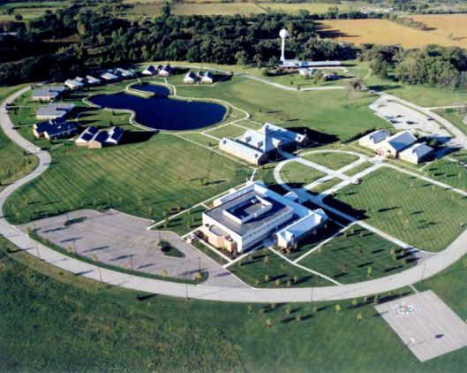
The average stay will be between 30 and 90 days. The facility will only accept self-pay patients and private health insurance.

All of the services will be provided by our experienced and trained team of professionals, who will be licensed by the State of Illinois. In addition to usual team of professionals, we will have a full time Medical Director licensed as an Addiction Psychiatrist and a Licensed Dietitian. All of our staff will undergo drug testing, and we will be a drug free workplace. Individual and group therapy will be given in each residence dormitory and will be tailored to the patients’ needs.

In addition to the medical care and addiction treatment, the facility will provide wellness and spiritual programs that include meditation, yoga, massage, and other therapeutic services. There will be a state of the art gym with group fitness classes and personal trainers. Art and nutritional classes will be offered. The existing gymnasium features a full size basketball court and will house many group activities (etc. Zumba, dancing).

The environment of the facility will feel more like a luxury spa than a treatment facility and will be dedicated to healing one’s whole self. The interiors of the common areas and residence dormitories will be renovated and include new furniture. We also will be upgrading the bathrooms with higher end finishes. Private and Semi-Private accommodations will be available. Out of town patients will be picked up at the airport by luxury SUV’s. The facility will be marketed to business executives, lawyers, doctors, celebrities, professionals, government workers, and their family members who are in need of treatment.

